**MBARARA UNIVERSITY OF SCIENCE AND TECHNOLOGY**   
**FACULTY OF COMPUTING AND INFORMATICS**   
**BIT ONE WEB DESIGN AND DEVELOPMENT**   
**BIT 1203 - WEB DESIGN AND DEVELOPMENT SEMESTER PROJECT REPORT (2025)**

AKAMPURIIRA JOHN VICTOR   
 2024/BIT/034/PS

**1. Project Overview**   
 **a. Project Purpose and Target Audience**   
The primary purpose of this website is to provide an informative platform for students and staff of JOHN VICTORS ONLINE TRADING to access university news, academic   
resources, and event updates. The target audience includes current students, prospective students, faculty members, upgrading students and university staff who require easy access to university-related information and services.

**b. Key Functionalities and Features**   
**Homepage:** Overview of the shopping site and announcements.

**Navigation Menu:** Links to various sections including Home, Shop, Vendors and Apply now.

**Responsive Design:** Compatible across desktops, tablets, and smartphones.

**Sell Form:** Allows users to send inquiries directly.

**Login Portal:** For Managers and Customers to access personalized information (mockup).

**c. Wireframes and Mockups**

Early wireframes were created using Figma, illustrating the homepage layout, navigation structure, and key sections. (Insert wireframe images here with captions). These guided the development process by establishing a clear visual hierarchy and user flow.

**2. Design Decisions**   
**a. Design Principles**   
**User-Centered Design:** Focused on ease of navigation and accessibility.

**Consistency:** Maintained uniform colour schemes, typography, and layout across pages. **Readability:** Used clear typography and appropriate color contrast.

**Aesthetic Appeal:** Balanced visuals with whitespace, adhering to color theory for a professional look.

**b. Rationale Behind Design Choices**   
**Color Scheme:** Blue and white colors evoke trust and professionalism, aligned with the Sells branding.

**Typography:** Times New Roman was chosen for its readability and formal appearance. **Navigation:** A top-fixed menu improves accessibility and user experience.

**Visuals:** Incorporation of high-quality images to engage users and showcase Online shopping life.

These choices enhance usability and create an engaging, trustworthy interface for users.

**c. Design Visuals**

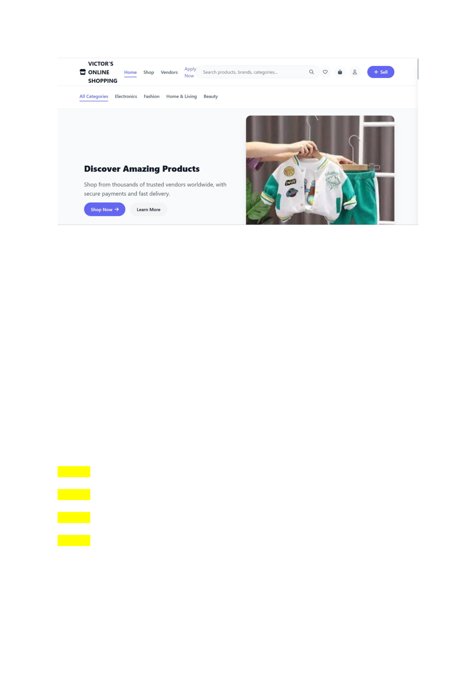

**3. Development Process**   
**a. Technologies and Frameworks Used**   
**HTML5:** Structure of web pages.

**CSS3:** Styling and layout design.

**JavaScript:** Dynamic content updates and interactivity. **Bootstrap Framework:** Responsive design components. **GitHub Pages:** Hosting the static website.

**b. Development Stages and Challenges**   
**Stage 1:** Planning and wireframing.

**Stage 2:** Implementing HTML structure and CSS styling. **Stage 3:** Integrating JavaScript for dynamic features.

**Stage 4:** Testing responsiveness across devices.

**Challenges:**   
 - Ensuring cross-browser compatibility.

- Making the website fully responsive on all device sizes.

- Handling layout issues with images and navigation.

**c. Solutions Implemented**   
- Used media queries in CSS to enhance responsiveness.

- Leveraged Bootstrap's grid system for consistent layouts.

- Conducted testing on multiple browsers and devices; refined code accordingly. - Consulted online resources and documentation to troubleshoot issues.

**4. Testing and Deployment**   
**a. Testing Strategies**   
**Responsiveness Testing:** Used Chrome Google Chrome and BrowserStack to simulate various devices.

**Functionality Testing:** Verified links, contact form submission (via dummy email service), and interactive components.

**Compatibility Testing:** Checked across browsers like Chrome, Firefox, and Edge to ensure uniformity.

**b. Deployment Method**   
The website was deployed using GitHub Pages, hosting the static files directly from the GitHub repository. This allowed easy access and updates without additional server configuration.

**c. Testing Visuals**

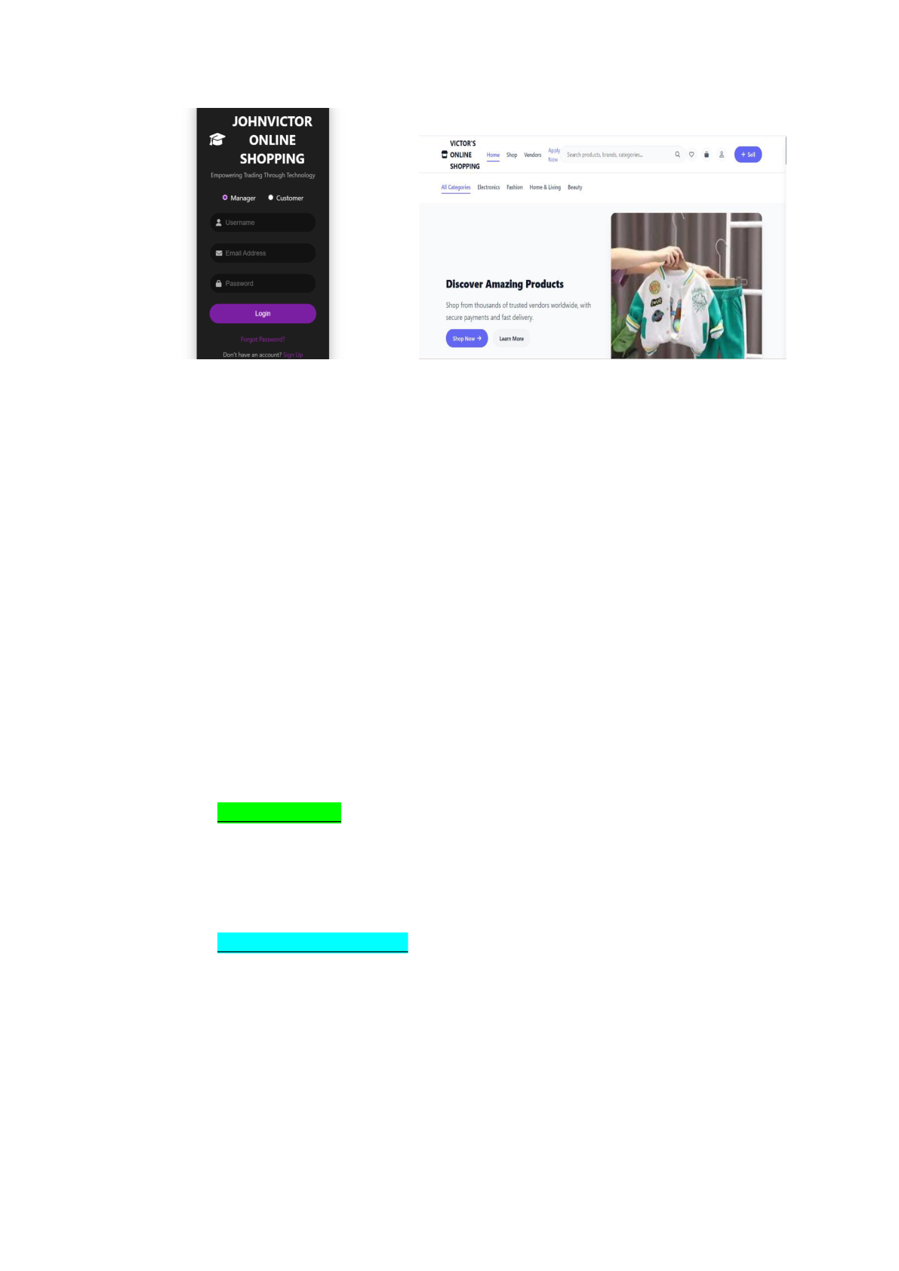

**5. Conclusion and Reflection**   
**a. Key Takeaways**  
- The project strengthened understanding of responsive web design and front-end development.

- Effective planning and wireframing are crucial for a smooth development process. - Utilizing frameworks like Bootstrap accelerates development and enhances consistency.

**b. Learning Experience**

*What Went Well:*   
- Seamless integration of design and development. - Successful deployment on GitHub Pages.

*What Could Be Improved:*   
- Incorporate backend functionalities for dynamic content in future iterations. - Improve accessibility features for users with disabilities.

**c. Future Considerations**   
- Adding a student login system with backend support.

- Implementing a content management system (CMS) for easier updates. - Enhancing security features, such as HTTPS and form validation.

**d. GitHub Repository Link**   
[Insert your GitHub link here]   
 -- - - - - - - - - -- - - - -- - - - -